f8-usva-tst Help-Scenario反馈 2026-6-12
https://crew-f8-usva-tst.roiscloud.com/fpqe/gantt/
Help菜单，Scenario部分，按顺序反馈

Scenario › Overview
这2个状态的颜色是一样的吗？
UI有一个颜色在Help里没有说明，不知道是什么状态
Ryan – this has been updated
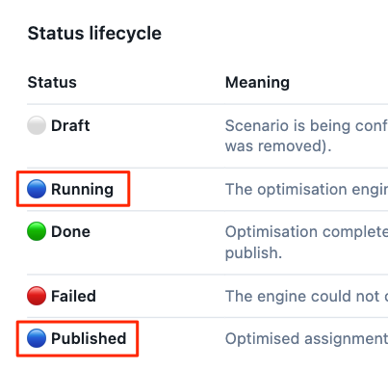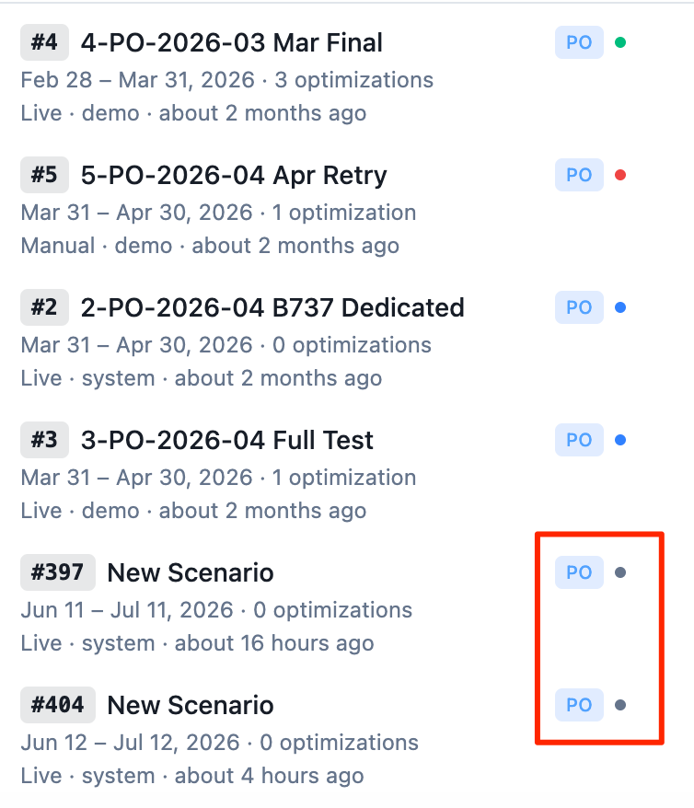

Scenario › Browsing and searching scenarios

Ryan – this is DOM inspector, we do have this
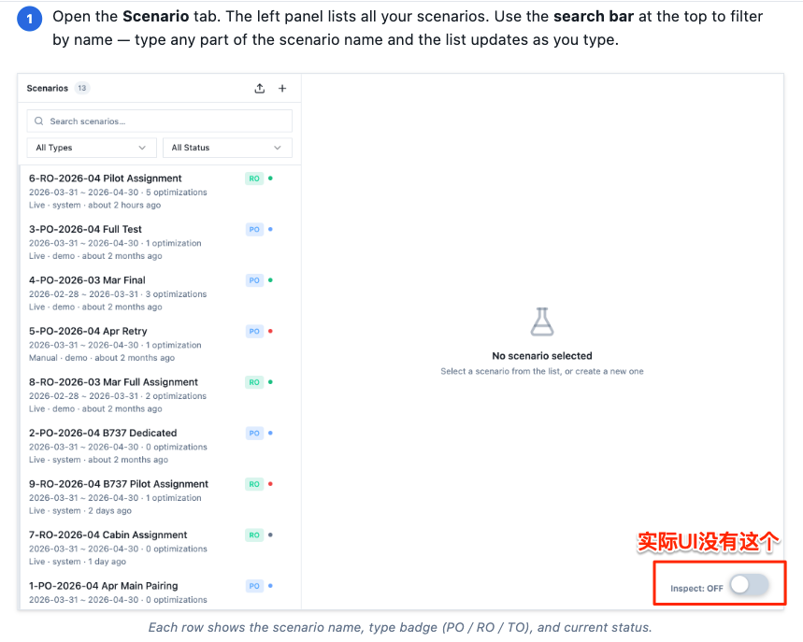

Scenario › Duplicating a scenario
红线标出的只有RO场景才有，PO场景就没有，这样描述是否不够普遍

Ryan – configuration of a scenario should be specific to scenario type, below is only for RO, need to add PO, RO and TO scenario specific configuration
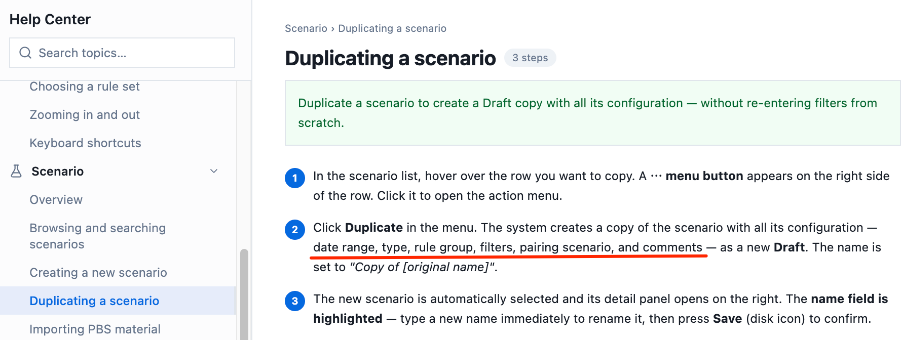

Scenario › Importing PBS material
红框功能，UI没有
Ryan – import PBS UI is ready but not wire with backend logic, mark it as (Partial – Wait for Backend service)
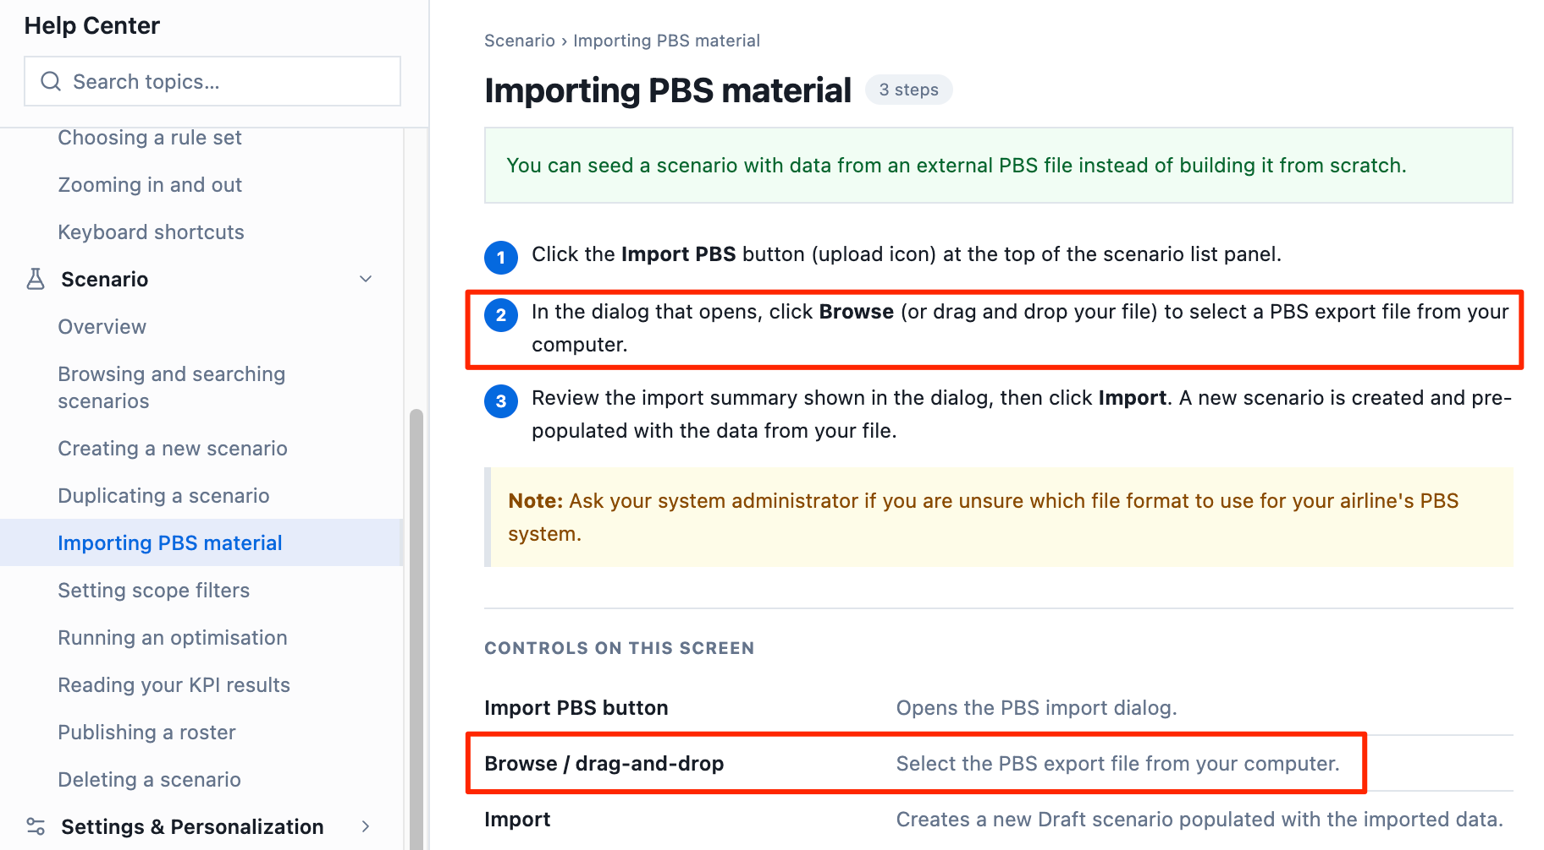

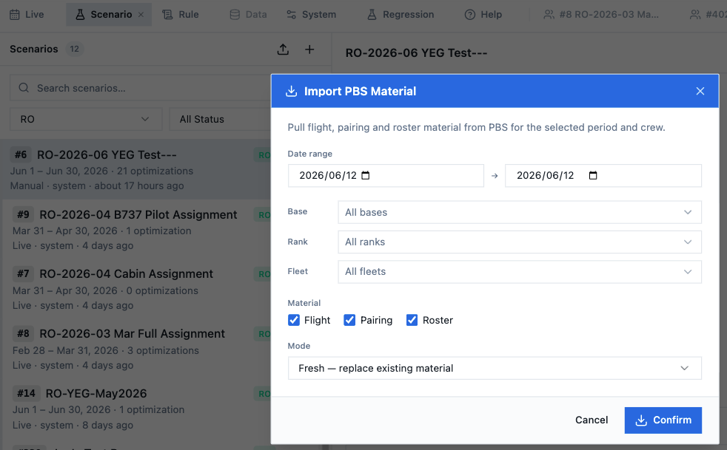

Scenario › Setting scope filters
问题1，以下红框描述，类型是否缺少Crew Bids

Ryan – crew bids was missed, use Jun 2026 YEG base data as example to introduce and take snapshot

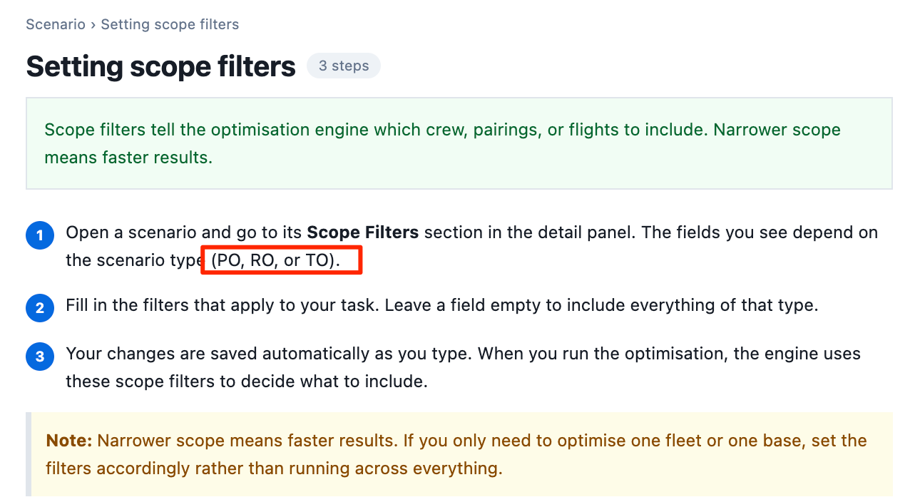
问题2：PO的Filter没有示意图，项目也和UI不符合
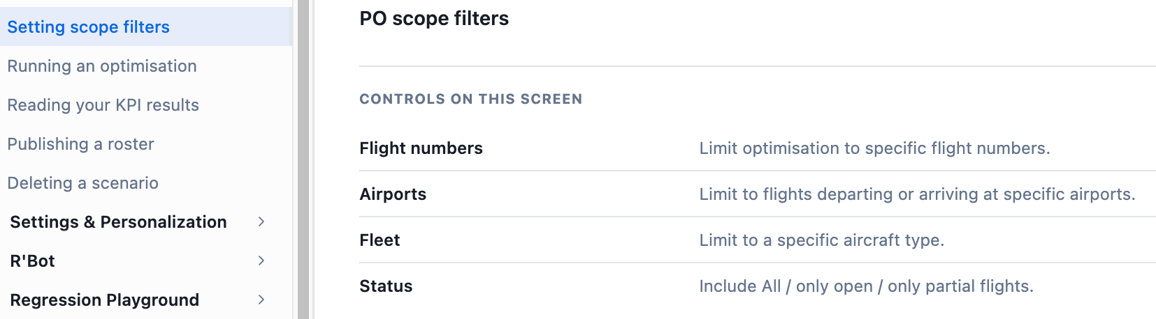
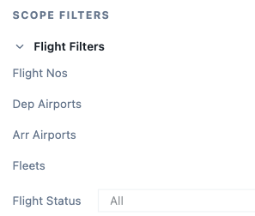

Scenario › Running an optimization
问题1：红框和UI不符合，UI是Rule是否也不合适？应该是Rule Set
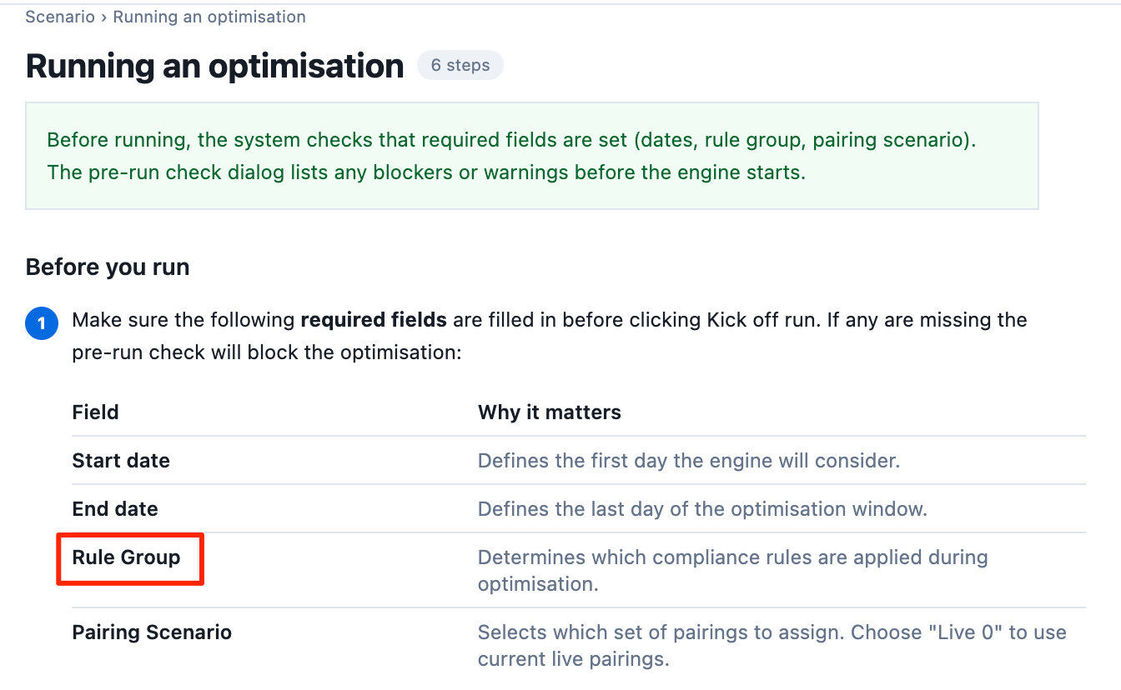
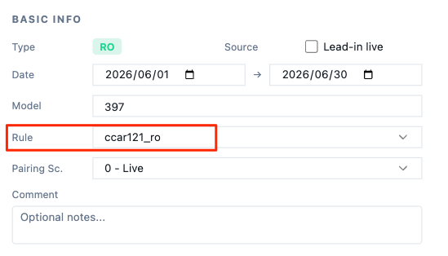

问题2：Pre-run Check dialog的图标，和UI不一致
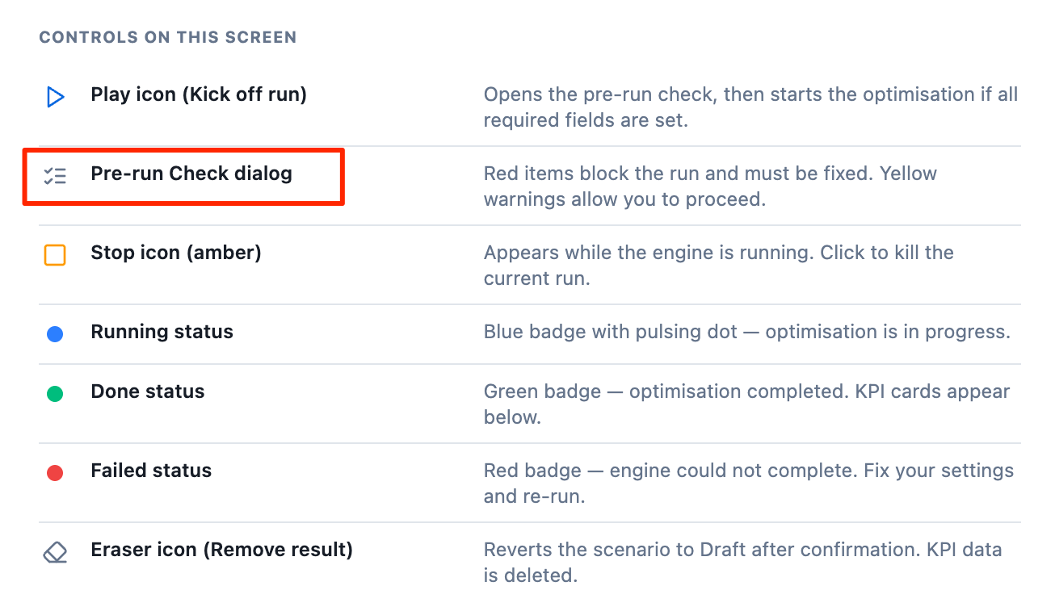
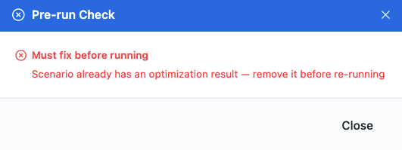

问题3：图标风格不一致
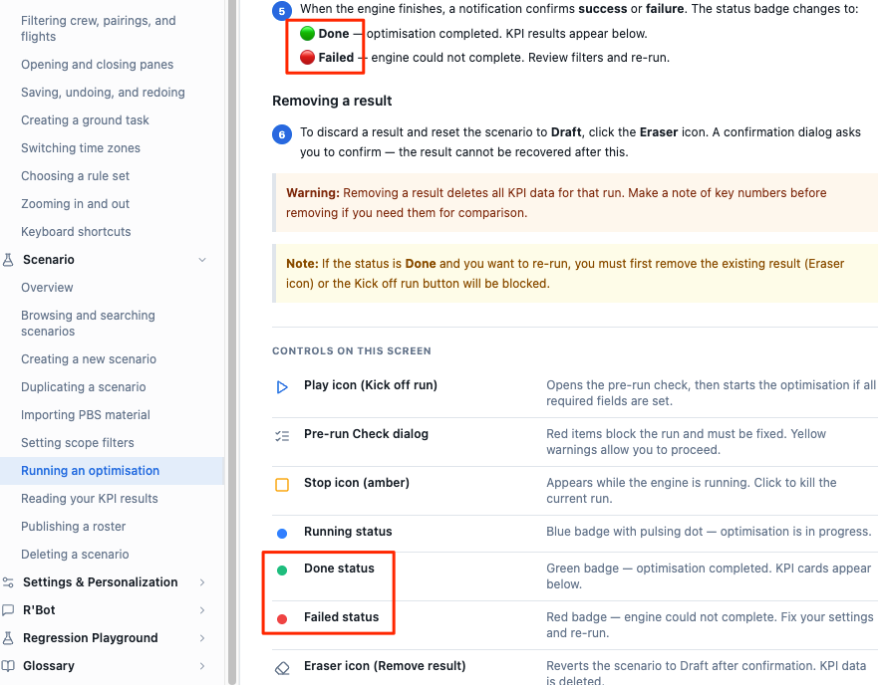

Scenario › Deleting a scenario
问题1：叫出菜单的方式，和Duplicating a scenario一模一样，但是文字描述不同？建议统一
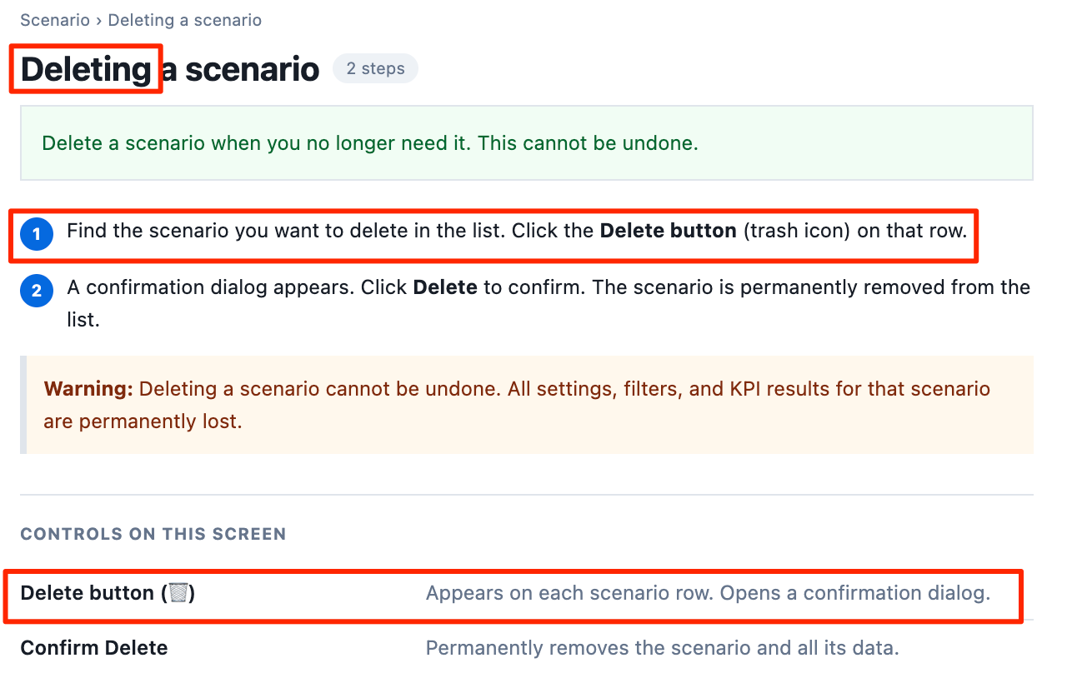

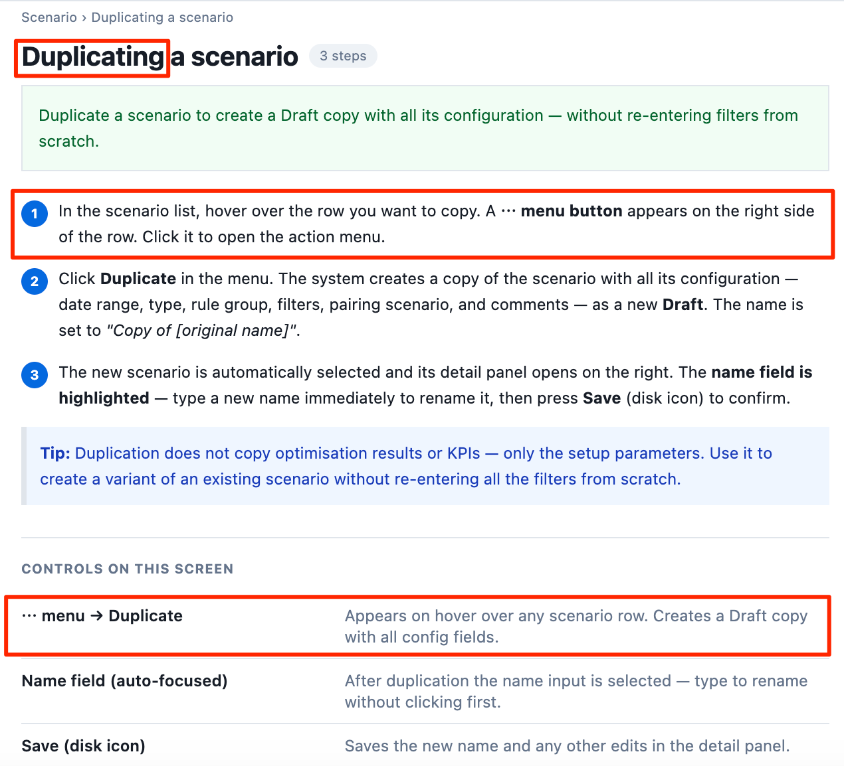
问题2：图标和UI不符合
